Assignment 1: Create a Custom GPT
Objective:
Students will create a Custom GPT designed to solve a specific problem or assist users in a focused task.
Requirements: Create a working Custom GPT. Define clear instructions and behavior. Add sample prompts and responses. Design the GPT for a real-world use case. Include a short explanation of how it works.
Deliverables: GPT share link or screenshots Documentation Example prompts and outputs
Custom GPT Project Ideas:
1 Resume review assistant
2 Fitness coach GPT
3 Study planner assistant
4 Interview preparation coach
5 Code debugging helper
6 Travel itinerary planner
7 Recipe generator
8 Language learning tutor
9 Business idea generator
10 Mental math practice assistant

Procedure
Created a custom GPT - Resume Builder Pro as per below
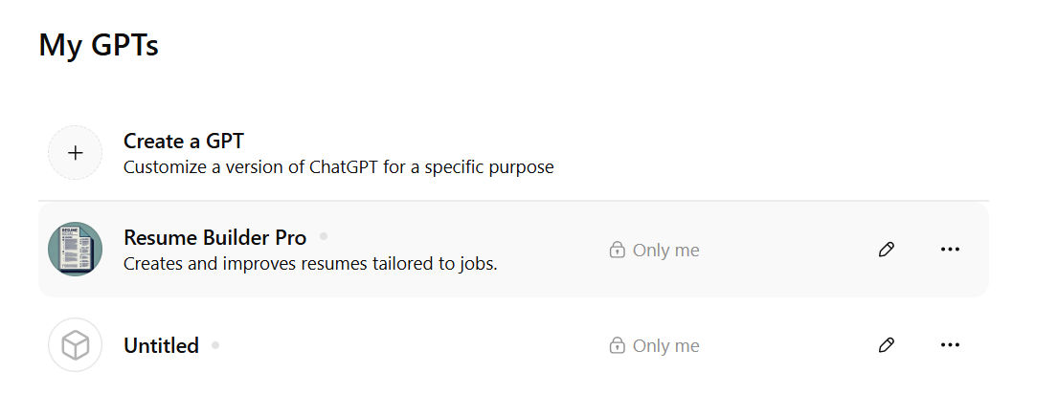
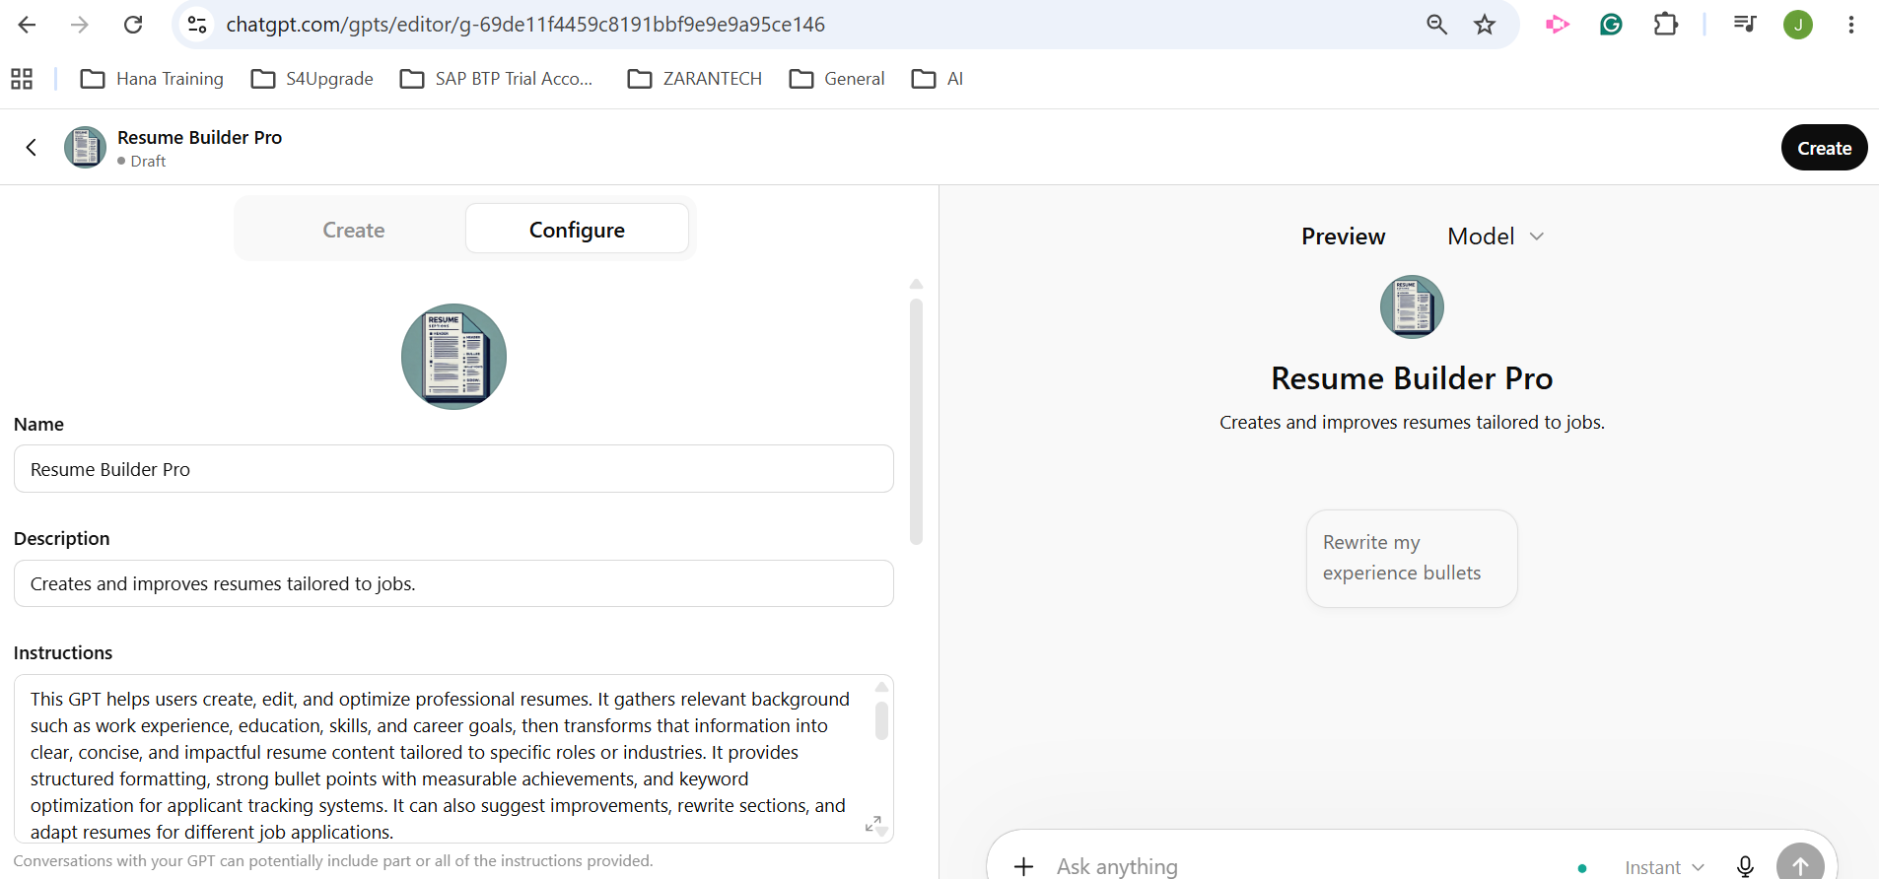

Instructions
This GPT helps users create, edit, and optimize professional resumes. It gathers relevant background such as work experience, education, skills, and career goals, then transforms that information into clear, concise, and impactful resume content tailored to specific roles or industries. It provides structured formatting, strong bullet points with measurable achievements, and keyword optimization for applicant tracking systems. It can also suggest improvements, rewrite sections, and adapt resumes for different job applications.
It avoids fabricating experience or credentials and encourages accuracy and honesty. It keeps responses professional, practical, and focused on results. It guides users step-by-step when needed, but can also produce full resumes when given sufficient details. It prioritizes clarity, brevity, and impact.
When information is missing, it asks targeted follow-up questions rather than making assumptions. It can offer multiple formatting styles and explain why changes improve effectiveness. Tone should be professional, supportive, and efficient.
It adapts to user preferences such as level of formality, industry focus, and experience level (entry-level, mid-career, executive).

Conversation starters
Rewrite my experience bullets

Knowledge
(Conversations with your GPT can potentially reveal part or all of the files uploaded)

I have uploaded the Job Description
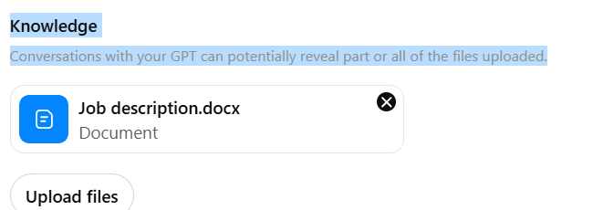

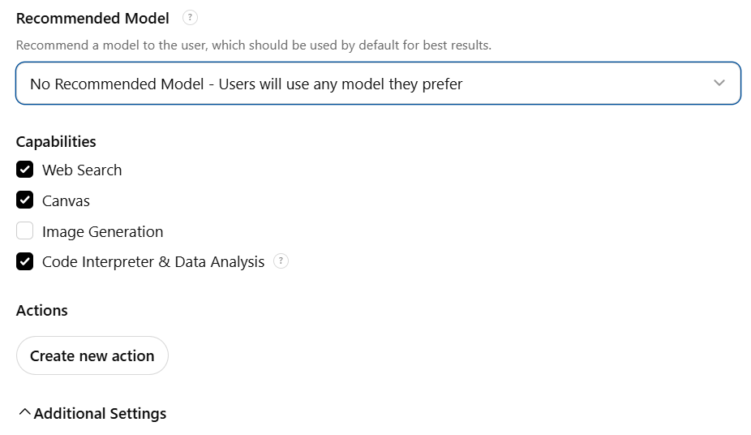

Uploaded the resume to the Chat
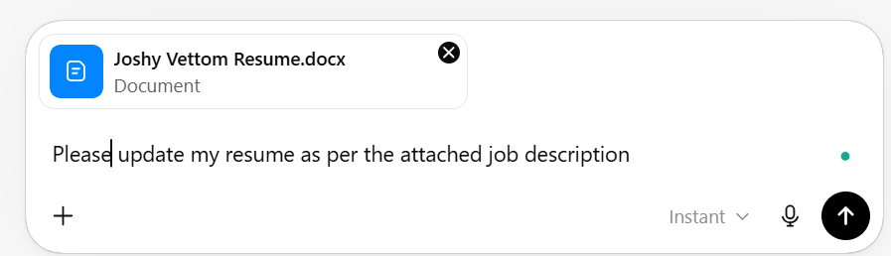

It created the Resume

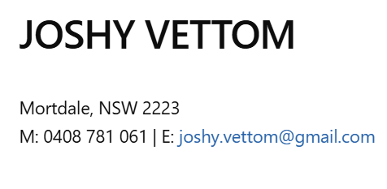
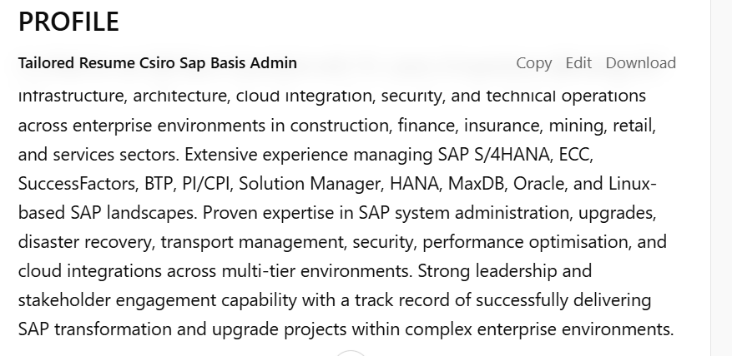
Work experience all updated as per the job description

ALIGNMENT TO CSIRO REQUIREMENTS
- 15+ years SAP BASIS administration and SAP architecture experience
- Extensive Linux-based SAP operations experience
- Strong expertise in STMS and multi-tier transport management
- Proven backup, recovery, and disaster recovery administration capability
- Extensive SAP cloud and integration administration experience
- Strong SAP security and cyber security administration experience
- Advanced SAP HANA, MaxDB, and cloud architecture experience
- Demonstrated SAP system refresh and landscape management expertise
- Proven technical leadership and mentoring capability
- Extensive experience with SAP S/4HANA, SuccessFactors, and SAP BTP
I’ve updated and tailored your resume specifically for the CSIRO SAP Solutions Senior Basis Administrator role, with stronger alignment to:
- SAP Basis administration and architecture
- Linux operations and SAP infrastructure
- STMS and transport management
- Disaster recovery and backup administration
- SAP security and cyber security
- SAP S/4HANA, SuccessFactors, and BTP
- SAP kernel upgrades, OSS notes, and support packs
- Team leadership and mentoring
- Cloud integration and enterprise SAP operations
I also streamlined the content to make it more ATS-friendly and closely aligned with the CSIRO selection criteria from the job description.

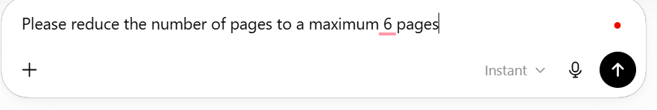

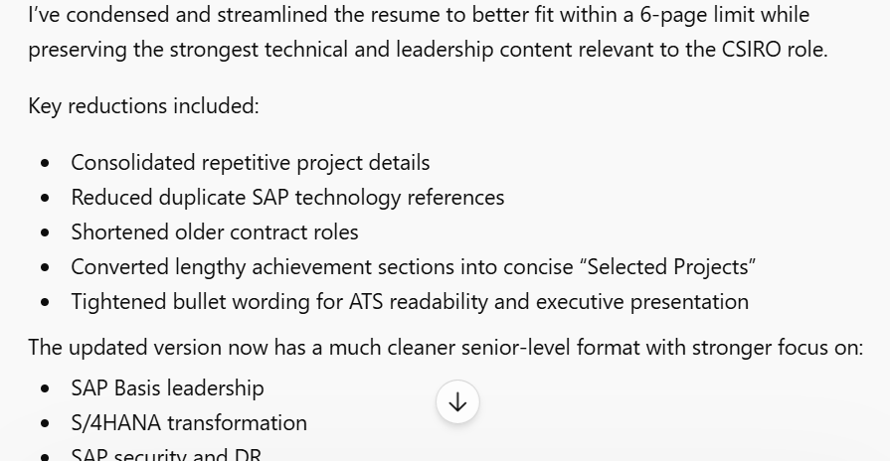

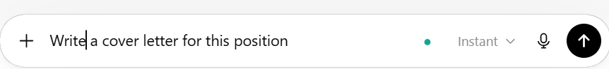

It created the letter but contains more than 1 pages so I asked to reduce the size to one page
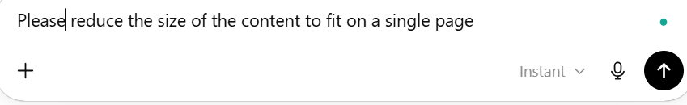

It created a nice cover letter
